NAME: NAVODITAA A.R.
ROLL NO: 241901071

Exercise 4

DEVELOP A CUSTOMISED PING COMMAND TO SERVER
AIM:
To develop a Python program using the socket module that tests server connectivity
(similar to the ping command) and measures the minimum, maximum, and average round-
trip time (RTT) for multiple connection attempts.

ALGORITHM:
1. Import socket and time modules.
2. Set host, port, and number of ping attempts (count).
3. For each attempt:
o Create a socket and record start time.
o Connect to the server and record end time.
o Calculate RTT = (end - start) × 1000 ms.
o Print RTT or “Request timed out” if connection fails.
4. After all attempts, compute and display min, max, and average RTT values.

CODE:
import socket
import time

host = ”google.com”;
port = 80 # HTTP port
count = 4 # number of pings

for i in range(count):
try:
s = socket.socket()
start = time.time()
s.connect((host, port))
end = time.time()
s.close()
print(f”Reply from {host}: time={(end-start)*1000:.2f} ms”)
except Exception:
print(”Request timed out”)

Customized Ping Program to Measure Min, Max, and Average RTT

import socket, time
host = ”google.com”;
port = 80
count = 4
times = []

for i in range(count):
try:
s = socket.socket()
start = time.time()
s.connect((host, port))
end = time.time()
s.close()
rtt = (end - start) * 1000
times.append(rtt)
print(f&quot;Reply from {host}: time={rtt:.2f} ms&quot;)
except:
print(&quot;Request timed out&quot;)

if times:
print(“\nMin RTT =”, min(times), “ms”)
print(“Max RTT =”, max(times), “ms”)
print(“Avg RTT =”, sum(times)/len(times), “ms”)

OUTPUT:
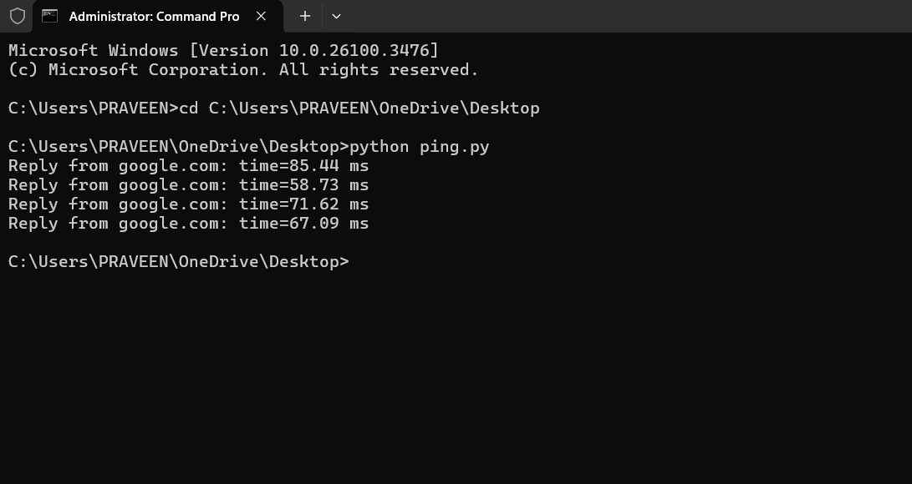

RESULT:
Thus, the program has successfully performed ping operation to google.com
,extracted RTT values from the response and computed min ,max ,and average RTT

